RESEARCH PROPOSAL
Beyond Hop Count: A Structural, Mechanistic and Predictive Account of Difficulty in Multimodal Agentic Retrieval
Proposed framework: SDM-MAR (Structural Difficulty Model for Multimodal Agentic Retrieval)
Principal investigator: Mahin
Department of Computer Science and Engineering, Bangladesh University of Business and Technology (BUBT), Dhaka
Draft dated 2 October 2026
Item | Summary
Study type | Scientific (explanatory and predictive) study with controlled interventions; not a new agent architecture.
Core question | Can the difficulty of multimodal agentic retrieval be predicted from structural properties beyond hop count: depth (H), concept-separation load (CSL), modality switches (MS) and retriever capacity (RC)?
Status | Idealised synthetic proof of concept completed. No real LLM/VLM agent results exist yet. Everything in Sections 12-13 about real agents is a hypothesis to be tested and could fail.
Honesty note | Novelty statements mean "not found in the literature I read", not "proven absent". Publication in a Q1 journal cannot be guaranteed; the plan is designed to meet what such reviewers typically check (assumptions, replicates, out-of-sample tests, honest limits).

Contents
Abstract
1. Title of the proposed model
2. Introduction
3. Problem statement
4. Short literature review of research papers
5. Research questions
6. Research objectives
7. What is already established (not claimed as novel)
8. What is specifically new in this proposal
9. Core novelty (scientific novelty, not model novelty)
10. Main research contribution
11. Related applications
12. Proposed model framework (structure, theory, experiments, statistics)
13. Our contributions that beat others (capability comparison)
14. Model novelty (and its honest limits)
15. References
16. Actual novelty and what other papers do, paper by paper
Appendix A. Dataset table (public, gated, private)
Appendix B. Structural annotation protocol and human validation
Appendix C. Pilot results (idealised simulation)
Appendix D. Risks, go/no-go rules and timeline
Appendix E. Reproducibility checklist and requirement coverage

Abstract
Agentic retrieval systems that read, plan, search again and combine evidence across text and images are usually compared by their final accuracy, and their difficulty is usually described by a single number: the number of reasoning hops. Hop count is a coarse description. Two questions with the same number of hops can differ in how many similar candidates must be kept apart, in how many times the evidence changes modality, and in how much representational capacity the retriever has. This proposal asks whether the difficulty of a multimodal retrieval question can be predicted, out of sample and across datasets, from four structural properties: retrieval depth (H), concept-separation load (CSL), the number of modality switches (MS) and the retriever's representation capacity (RC).
The work is a scientific study, not a new agent. It combines (i) a formal statement of bridge-blindness and a bound on how product-form accuracy can fail under dependence, (ii) structural annotation of real multimodal multi-hop questions, (iii) repeated runs of three vision-language agent families, (iv) three interventions (oracle bridge, image-to-caption, retriever dimension) that each change one factor with a stated predicted direction, (v) a head-to-head predictive comparison of a hop-count baseline, retrieval-score features and the structural model, (vi) frozen-coefficient transfer from the discovery dataset (CrossModalQA) to three external datasets, and (vii) a mechanism-labelled failure analysis. A first idealised simulation supports the depth part of the hypothesis, refutes my own earlier width conjecture, and motivates replacing width by concept-separation load. Real-agent behaviour is not yet established, and the plan contains explicit go/no-go rules and a pre-committed negative-result report.

1. Title of the Proposed Model
Study title. Beyond Hop Count: A Structural, Mechanistic and Predictive Account of Difficulty in Multimodal Agentic Retrieval.
Model name. SDM-MAR (Structural Difficulty Model for Multimodal Agentic Retrieval).
What the "model" is. SDM-MAR is a calibrated statistical model of difficulty, not a neural architecture. It has two linked parts: a question-level model that predicts P(success | question) from the structure vector s(q) = (H, CSL, MS, edge-type counts, RC), and a hop-level model that predicts the success of each hop from its edge type and the outcome of the previous hop, and composes into a question-level prediction. Section 14 states precisely how little of this is claimed as model novelty.

2. Introduction
Retrieval-augmented generation has moved from a single retrieve-then-read step to agentic loops in which a model decides what to search for, reads the results, forms a new query and repeats. The same shift is happening for multimodal material: scanned reports, slides, charts, figures, product pages and image collections. Benchmarks now show large gaps. On a benchmark of visually rich documents, a strong visual retriever reaches 97.50% Recall@1 on direct items but 2.50% on items that need two bridging steps, while the best agent reaches 67.50% [11]. On a browsing benchmark, humans reach 68% and the best model 39% [13]. Evidence-grounded generation can reach about 81% with gold evidence but about 51% with top-5 retrieved evidence [14].
These are measurements. What the field lacks is an explanation that tells a practitioner, before running an expensive agent, which questions will be hard and why, and which remedy (a deeper loop, a larger retriever, better image handling) should help. Theory exists for neighbouring pieces: a limit on what a single d-dimensional vector can represent [1], a counter-result showing that margin-based embeddings need far fewer dimensions [2], an expressiveness gap between single- and multi-vector retrieval [3], and a single-pass accuracy bound that explicitly excludes retrieval and agentic search [4]. The authors of the dimension-limit study state that iterative retrieval is unexplored. Empirical work separates wide search from deep search [5][6] and shows that iterative retrieval helps bridge-heavy questions [8][9], but does not give a predictive account.
This proposal fills that gap with a measured, falsifiable, cross-dataset account. It treats difficulty as a function of structure, D = f(H, CSL, MS, RC), and tests whether that function predicts real agent outcomes better than hop count alone.
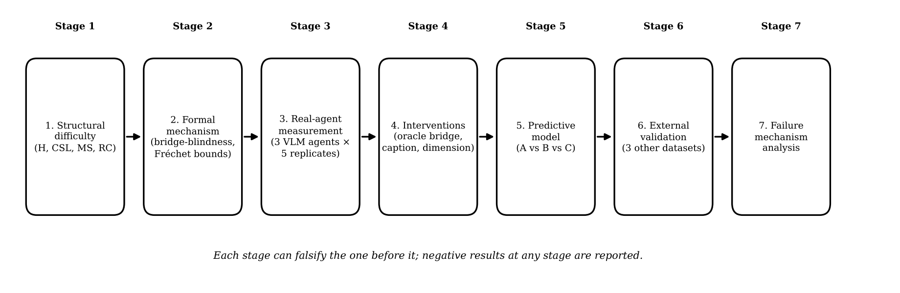
Figure 1. The scientific story of the proposal: seven stages, each able to falsify the previous one.

3. Problem Statement
Observed problem. Reported difficulty of multimodal agentic retrieval is described mainly by hop count and by final accuracy. Hop count cannot explain why questions with equal hops differ greatly in difficulty, why increasing retriever size sometimes helps and sometimes does not, or why image-dependent steps seem to be failure points.
Formal problem. Given a question q, a multimodal corpus C and an agent A with a retriever of dimension d, let Y(q, A) in {0,1} be success and π(q, A) = P(Y = 1 | q, A) the success probability over agent randomness. Find a low-dimensional, interpretable structure vector s(q) and a function f such that π is predicted out of sample, across datasets and across agents, markedly better than from hop count alone, and such that each component of s(q) has a distinct, testable mechanism and remedy.
Four concrete gaps.
- No factor separation. Depth (sequential dependence) and concept-separation load (how many similar concepts must be kept apart) are both folded into "multi-hop difficulty", although theory suggests they respond to different remedies.
- Modality is treated as a label, not as a structural variable. Where in the chain the evidence changes between text and image, and in which direction, is rarely analysed as a predictor.
- No test of the product intuition on real agents. If each hop must succeed, accuracy should decay roughly as a product of per-hop success; whether real agents show independent, correlated or error-propagating failures is untested for multimodal chains.
- No cross-dataset predictive validation. Findings from one benchmark are rarely frozen and tested on another.

4. Short Literature Review of Research Papers
The review below is organised by strand. All arXiv identifiers were read at abstract or summary level; items that could not be read are flagged in Section 16. Table 1 gives the strands; Section 16 gives the paper-by-paper comparison.
Table 1. Literature review by strand: what is established and what is missing.
Strand | Refs | What is established | What is missing
Embedding capacity theory | [1][2][3] | A single d-dimensional vector cannot realise all top-k subsets (lower bound on d from log C(n,k)); a counter-result gives d = O(k log(n/k)) for k-sparse margin settings; multi-vector retrieval is provably more expressive. All are single-stage. | No treatment of multiple rounds, bridge dependence or images. LIMIT's authors say iterative retrieval is unexplored.
Single-pass reasoning bound | [4] | A Fano-style bound: accuracy is limited when the information a task demands exceeds model capacity (an "accuracy cliff"). | Closed-book and single-pass; excludes retrieval and agentic search.
Wide vs deep search | [5][6][7] | Broad tasks (WideSearch: best system about 5%) and deep tasks differ; parallel agents help breadth; multi-query expansion gives about +4.4% on average; hybrid search gives +15.9 F1 on FanOutQA. | Empirical; no formal link to embedding dimension, depth or modality; no predictive model.
Iterative retrieval in practice | [8][9][10] | Iteration helps bridge-heavy questions (+3.74% on 2Wiki, +8.41% on MuSiQue), fails on single-hop, and bridge documents are often buried beyond top-10; failures cluster and are predictable from retrieval features. | Text only; observational; features are retrieval scores, not question structure.
Multimodal agentic and document benchmarks | [11][12][13][14][24][36] | Bridge levels (97.50% to 2.50% R@1), single vs multi-hop document queries, hop-annotated browsing, large mixed corpora (46,000 items), image-centric browsing. | They measure collapse; they do not explain it or predict it from structure, and they differ in structure so findings are rarely transferred.
Multimodal multi-hop datasets | [15][16] | CrossModalQA keeps supporting evidence subgraphs (1,863 QA, mean 3.50 hops); MultimodalQA reasons over text, tables and images. | Subgraphs exist but are not used to predict agent difficulty; path categories partly describe structure (to be checked).
Cross-modal conflict | [17][18][19] | Conflicting image/text evidence lowers accuracy (0.17-0.46 drops in CMC-Bench) and models prefer a fixed modality. | Static, engineered, not a retrieval trajectory; a different question from structural difficulty.
Causal and failure attribution | [20][21][22] | Fault injection at a hop; causal replay of agent runs; marginal vs common-random-number effects. | Text-only or general agents; no multimodal structure; small samples.
Evidence fusion and uncertainty | [23][28] | Conflict-preserving belief fusion; confidence calibration for extraction. | Not about structural difficulty.
Agent success prediction | [37] | Per-task success of agents can be predicted from task-level features (AUC 0.67-0.92 reported). | Methodological precedent only; not retrieval structure; reference entry incomplete.
Method papers in agentic RAG | [25][26][31] | Controllers, stopping rules, checklists, data evolution, logical retrieval. | Crowded; method contributions are not the target of this proposal.

5. Research Questions
- RQ1 (prediction). Do structural variables (H, CSL, MS, RC) predict per-question success of multimodal agentic retrieval out of sample better than hop count alone and better than retrieval-score features?
- RQ2 (separability). Do depth, concept-separation load and modality switches contribute separable effects, with ablations showing each is needed?
- RQ3 (mechanism by intervention). Do the three interventions change success in the pre-stated directions: oracle bridges help deep questions most; captions help modality-switch edges but not text-to-text edges; larger retriever dimension helps concept-separation-heavy questions but not deep ones?
- RQ4 (hop dependence). Do real agents follow the product-of-per-hop-success form, or do failures correlate or propagate?
- RQ5 (edge-type reliability). Does per-hop reliability differ by edge type (T→T, T→I, I→T, I→I), and is image-to-text extraction the weakest link?
- RQ6 (transfer). Does a model fitted on CrossModalQA predict outcomes on VisDocAgentBench, Double-Bench and BrowseComp-V3 without refitting?
- RQ7 (failure mechanisms). Which failure mechanisms (wrong bridge, wrong query, wrong image interpretation, retrieval miss, chain break, recombination failure) dominate in each structural cell?

6. Research Objectives
- Define and release operational, reproducible measures of H, CSL, MS, edge type and RC, with human validation on at least 100 questions.
- Prove, under explicit assumptions, a bridge-blindness lower bound on rounds and a bound relating the product law to dependence (Section 12.2).
- Measure P(success | question) with at least three independent agent families and five replicates per question.
- Quantify, with ablations, the contribution of each structural factor to out-of-sample prediction beyond hop count.
- Run oracle-bridge, image-to-caption and dimension interventions and compare outcomes to pre-stated predictions.
- Validate the frozen predictor on three external datasets.
- Produce a mechanism-labelled failure taxonomy and release code, prompts, seeds and annotations.

7. What Is Already Established (Not Claimed as Novel)
The following are known and are used as background, never as contributions:
- Multi-hop questions are harder than single-hop questions, and iterative retrieval helps bridge-type questions [8][9].
- A single dense vector has representational limits [1], and those limits are debated [2]; multi-vector retrieval is more expressive [3].
- Wide and deep search are empirically different, and parallel search helps breadth [5][6].
- Multimodal agents lose accuracy on bridge-dependent items [11][13] and retrieval from realistic corpora is much worse than from gold evidence [14].
- Conflicting cross-modal evidence hurts models [17][18][19].
- Failure at one step can be probed by fault injection and causal replay in text-only agents [20][21][22].
- Task-level success of agents can be predicted from task features [37].
- Agentic RAG methods such as evidence checklists, learned stopping, budget control and conformal stopping are already crowded; this proposal does not propose another one.
- A chain succeeds only if every link succeeds, so independent per-hop success multiplies. This is arithmetic, not a finding.

8. What Is Specifically New in This Proposal
"New" below means not found in the papers read for this proposal; the search is limited and some papers could not be read (Section 16).
- Concept-separation load as a measured, per-question variable separated from depth, replacing a width notion that my own simulation refuted (Appendix C).
- Modality-switch edges as structural predictors of agentic retrieval difficulty, with direction (T→I versus I→T) and edge type in the model.
- A single predictive model combining the four factors with the head-to-head comparison against hop-count and retrieval-score baselines, evaluated by AUC, Brier score, log-loss and calibration.
- A hop-level model with an error-propagation term that nests the product law as the independent special case and quantifies the departure on real multimodal trajectories.
- Three one-factor interventions with pre-stated directions applied to the same questions.
- Frozen-coefficient cross-dataset transfer across four multimodal benchmarks with different structures.
- A formal statement of bridge-blindness as a testable margin condition and a dependence bound on the product law (modest in mathematical depth, but measurable on real data).

9. Core Novelty (Scientific Novelty, Not Model Novelty)
Core scientific claim (to be tested; it can fail). The difficulty of a multimodal agentic retrieval question has separable structural causes, each with its own mechanism and remedy, and these causes predict agent success out of sample beyond hop count.
What is scientifically new is the type of knowledge produced: not a system that scores higher, but an explanation that (i) names the factors, (ii) states a mechanism for each, (iii) predicts what intervention should help which question, (iv) is tested on real agents with interventions that could have contradicted it, and (v) is frozen and tested on other datasets.
Table 2. The four factors, their mechanism, the predicted remedy and the intervention that tests it.
Factor | Definition | Mechanism (hypothesis) | Predicted remedy | Test
Depth H | Number of sequential evidence hops where query j+1 needs a bridge revealed at hop j | Bridge-blindness: later evidence cannot be found from the question alone, so rounds are needed and per-hop errors multiply | Oracle bridge; deeper loop; verification/backtracking | Oracle bridge: gain should increase with H
Concept-separation load CSL | How many similar concepts the retriever must keep apart (hard-negative neighbourhood) | Consumes representational capacity; related to dimension counting arguments but not identical to them | Larger or multi-vector retriever; reranker | Dimension sweep: gain should increase with CSL, not H
Modality switches MS | Number of edges where the evidence moves between text and image | Bridge information may exist only in visual content, so text-only access gives no margin for the next hop | Image-aware retrieval; captions; OCR | Image-to-caption: gain should increase with MS and for T→I / I→T edges only
Retriever capacity RC | Representation dimension d, retriever type (single or multi-vector) | Upper limit on what one query can separate; effect may be non-monotone | Choice of retriever | Dimension sweep d = 32 to 512

Why this is more than "it depends on hops". If hop count alone predicted success as well as the structural model, the proposal would report that hop count suffices, which is also a publishable and useful negative result. The contribution is the test, not a guaranteed positive finding.

10. Main Research Contribution
- A measurable framework: operational definitions of H, CSL, MS, edge type and RC for evidence graphs of multimodal questions, with released annotation code and a human-validated subset.
- A formal result set: a bridge-blindness lower bound on rounds under stated assumptions and Fréchet-type bounds on end-to-end success under dependence, with the assumptions testable on data.
- A real-agent evidence base: repeated-run success probabilities for at least three vision-language agent families on a primary multimodal multi-hop dataset.
- A predictive model with a fair test: structure-based predictor against hop-count and retrieval-score baselines, with ablations, calibration and cross-dataset transfer.
- Interventional evidence: three single-factor interventions and their agreement or disagreement with pre-stated predictions.
- A mechanism-labelled failure analysis across edge type, depth and concept-separation load.
- Open artefacts: annotation code, prompts, seeds, run logs and analysis code.

11. Related Applications
Application | How the framework helps | Condition / status
Cost and routing | Predict, before running an agent, which questions are deep, load-heavy or modality-switching, and route them to a stronger or slower pipeline. | Needs calibrated probabilities (evaluated in Section 12.5).
Retriever and agent diagnosis | Tell a practitioner whether the right fix is a larger retriever, an image-aware step, or a deeper loop. | Needs the intervention results to hold.
Benchmark design | Report difficulty by structural cell rather than overall accuracy; build balanced test sets; detect benchmarks dominated by shallow items. | Annotation code makes this reusable.
Enterprise document intelligence | Financial reports, technical manuals, slide decks and scientific papers where answers span text, tables and figures. | Domain datasets listed in Appendix A.
Medical and scientific literature search | Multimodal evidence chains (text report plus imaging or chart). Relevant to the author's interest in medical imaging; needs separate permissions and datasets. | Not tested in this proposal; stated as a transfer target only.
Education and e-commerce QA | Questions grounded in textbook figures or product images and specifications. | Not tested in this proposal.
Safety and auditing | Deep or image-dependent items are where agents are least reliable, so they are where human review is most needed. | Follows from the failure analysis.

12. Proposed Model Framework

12.1 Overall framework
SDM-MAR has five components (Figure 2): a structural annotator that turns each question into an evidence graph and a structure vector; an agent runner with controllable retriever dimension and full per-hop logging; an intervention engine that changes one factor at a time; the structural difficulty model with its baselines; and the evaluation and failure-analysis stage.
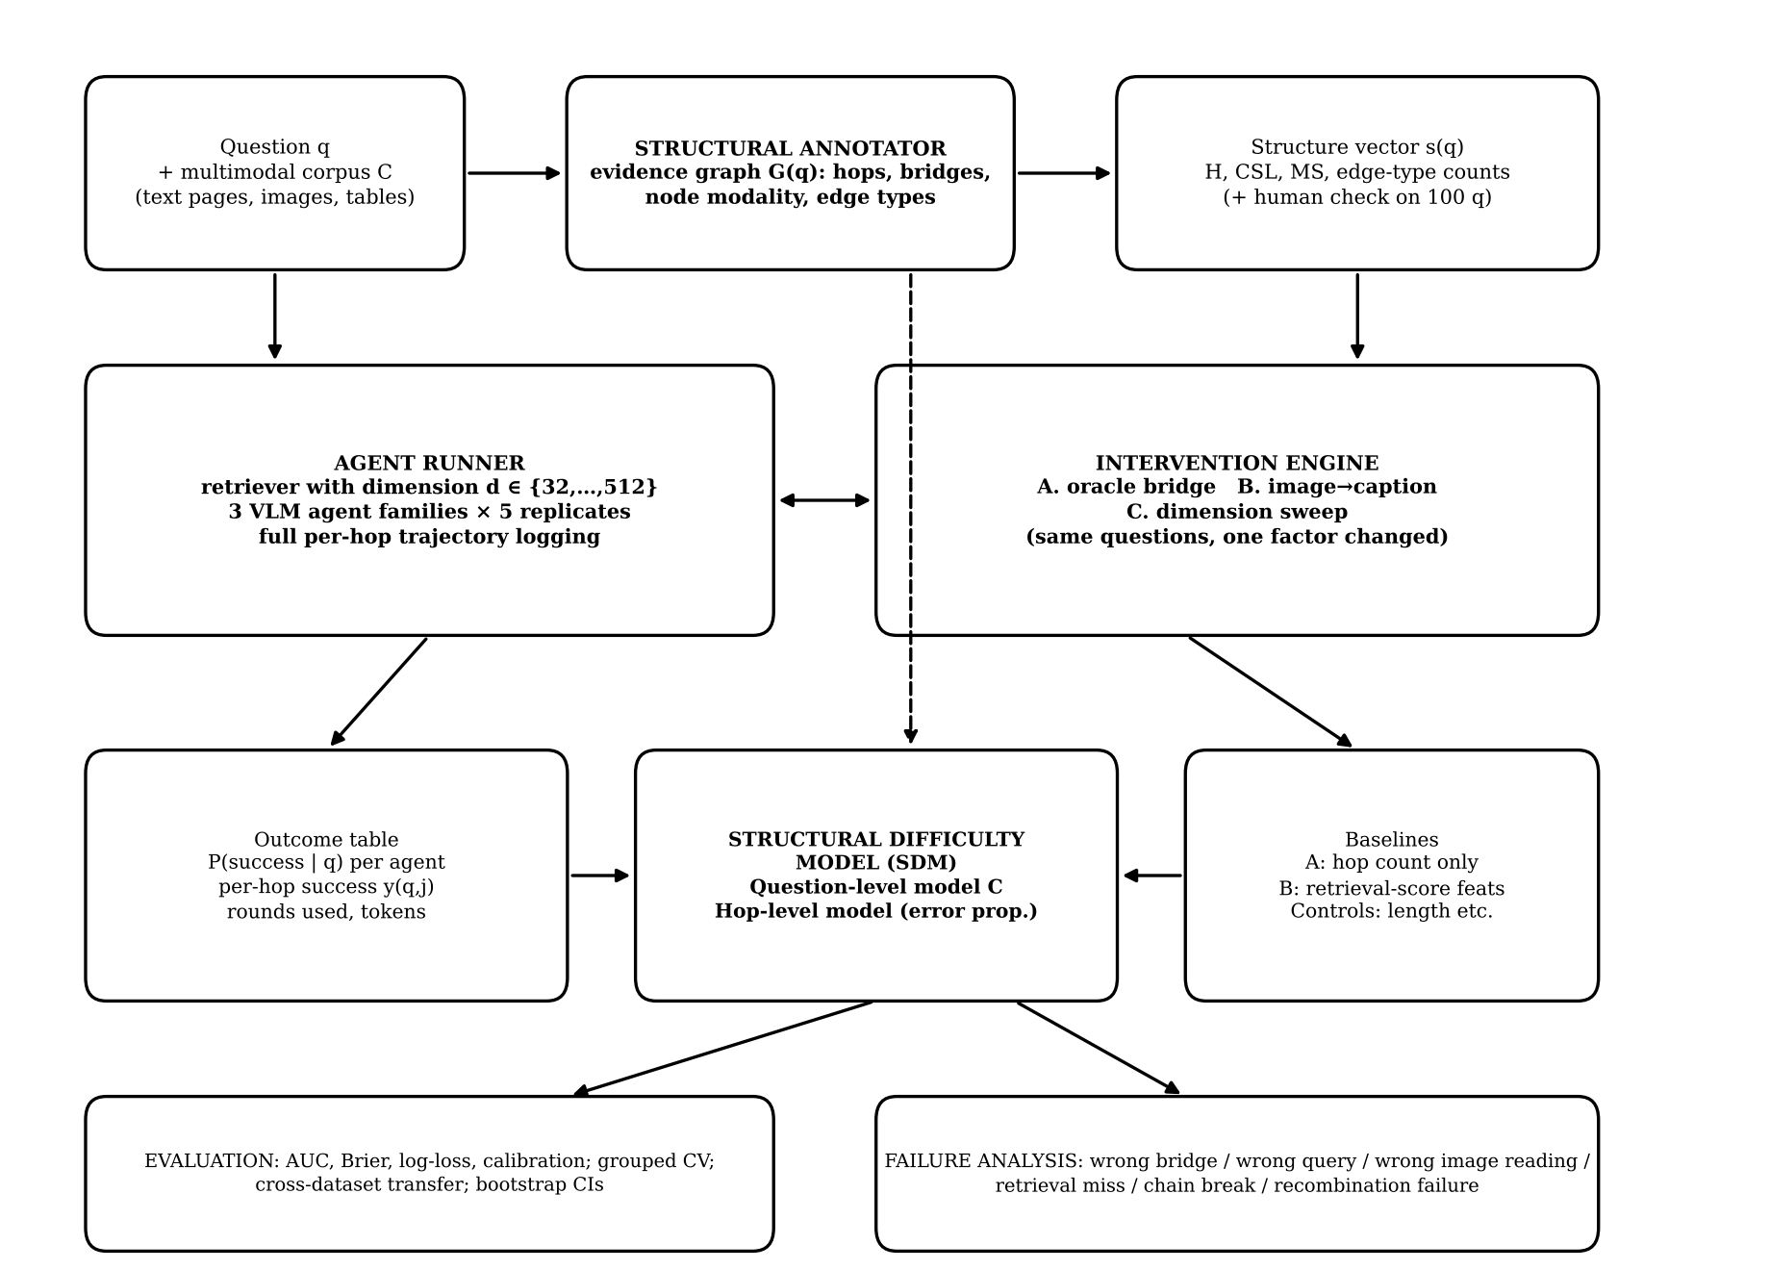
Figure 2. Proposed model framework of SDM-MAR.

12.2 Formal part
Setting. A question q has a gold chain of evidence items e1, …, eH. A retrieval round returns a set R of m items for a query that is a function of q and everything read so far. A bridge entity bj is an entity or value that appears in ej-1 and is needed to identify ej.
Assumption A1 (bridge-blindness, measurable). For every j ≥ 2, ej is not in the top-K list for any query that can be computed from q and from the items read before ej-1 is read. Operationally: the margin of ej against q (score of ej minus the K-th score) is negative for the retriever used, and bj does not occur in q.
Proposition 1 (round lower bound). Under A1, the first round in which ej can be retrieved is later than the first round in which ej-1 has been retrieved. Hence ej can be retrieved no earlier than round j, and any procedure that retrieves eH needs at least H rounds.
Proof sketch. By induction on j. For j = 1 the claim is trivial. Suppose ej-1 cannot be retrieved before round j-1. A query before ej-1 is read is a function of q and items other than ej-1; by A1 it does not retrieve ej. So ej can first be retrieved in a round after ej-1 has been read, which is at least round j. ∎
Honest comment. Proposition 1 is simple. Its value is that A1 is a checkable condition on real data (margin test), that its violation rate can be reported, and that the rounds bound is exactly what the oracle-bridge intervention removes. It is not claimed as deep mathematics.
Proposition 2 (dependence bounds on the product law). Let hop events Sj = {hop j succeeds} have marginal probabilities pj. Then, whatever the dependence,
max(0, 1 − Σj (1 − pj)) ≤ P(S1 ∩ … ∩ SH) ≤ min_j pj .
Independence gives ∏ pj, which lies between these bounds. Consequence: if measured end-to-end success lies far from ∏ pj (for example near min pj), failures are positively dependent; if it lies below, errors propagate (a failed hop degrades the next query). Both are measurable, and the hop-level model below quantifies them. These are the Bonferroni and Fréchet inequalities, applied to this setting.
Conjecture (not claimed as proved). Concept-separation load consumes representation capacity in the manner of dimension-counting arguments [1][2]: for a fixed retriever, the dimension needed to keep Q distinct concepts apart grows with Q rather than with the size of each relevant set. Evidence so far is only an idealised simulation (Appendix C) and this will be tested empirically, not proved.
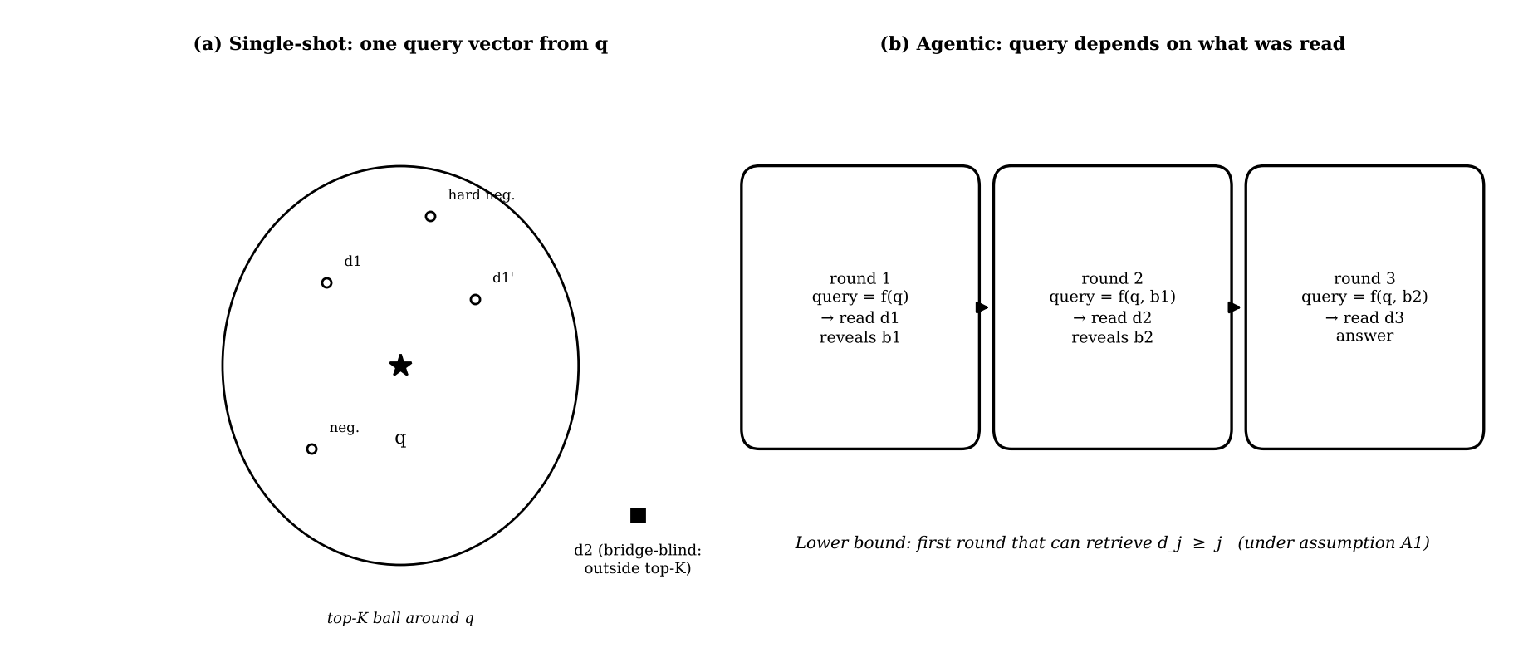
Figure 3. Bridge-blindness: a single query vector built from q cannot reach d2; an agentic loop reaches it after reading d1.

12.3 Structural variables and annotation
Evidence graph. Each question is annotated with a directed graph G(q): nodes are evidence items (a page, a passage, an image, a table) with modality in {T, I}; edges are bridge dependencies (the output of node j is needed to query node j+1).
Variable | Definition | Source
H (depth) | Length of the longest dependency chain in G(q). | From CrossModalQA subgraphs; from bridge levels in VisDocAgentBench; from hop metadata in BrowseComp-V3 and Double-Bench; by annotation otherwise.
MS (modality switches) | Number of edges whose endpoints have different modality. | From node modalities.
Edge type | Counts of T→T, T→I, I→T, I→I edges. | From node modalities and direction.
CSL (concept-separation load) | Primary: log2 of the number of corpus items within the retriever's similarity margin of the gold item at each hop, summed over hops (hard-negative neighbourhood size). Secondary: number of distinct entity/concept constraints in the hop queries. | Computed from the corpus and retriever; the primary and secondary definitions are both pre-registered and a sensitivity analysis compares them.
RC (capacity) | log2 d of the embedding dimension; retriever type (single-vector or multi-vector). | Set by experiment design.
Controls | Question length, evidence length, number of images, answer type. | Used to show gains are not trivial.

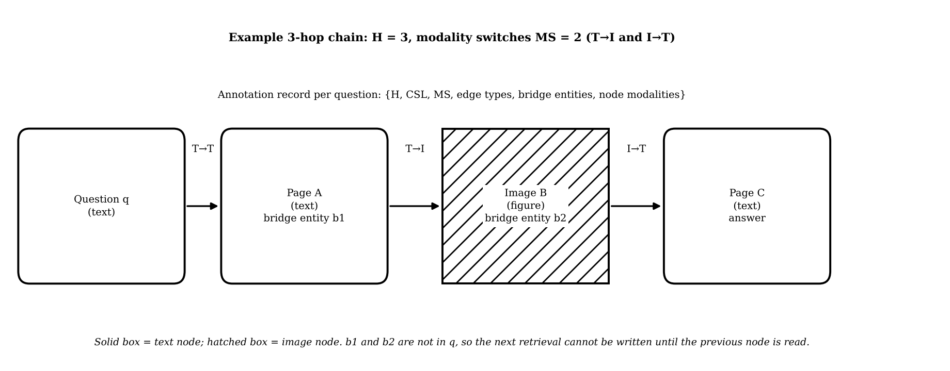
Figure 4. Evidence graph for a 3-hop question with two modality switches and the annotation record.
Human validation. 100 questions are annotated independently by two people for hop count, evidence chain, modality labels, bridge entities and CSL tier; agreement with automatic annotation is reported with Cohen's kappa for categorical fields and intraclass correlation for counts.

12.4 Agents, replicates and interventions
- Agents. At least three independent vision-language agent families with the same tool set (search, page/image read), the same round budget, and the same retriever; exact model version, date and settings logged.
- Replicates. Five runs per question and configuration, giving an estimate of P(success | question) rather than a single binary outcome.
- Intervention A, oracle bridge. Replace the normal chain q → R1 → bridge → R2 with q + gold bridge → R2. Prediction: gain grows with H.
- Intervention B, image to caption. Replace text → image → text with text → caption → text, captions produced once and fixed. Prediction: gain grows with MS and on T→I and I→T edges only.
- Intervention C, dimension sweep. d = 32, 64, 128, 256, 512 on the same questions. Prediction: gain grows with CSL and not with H; the effect may be non-monotone (as in the simulation).
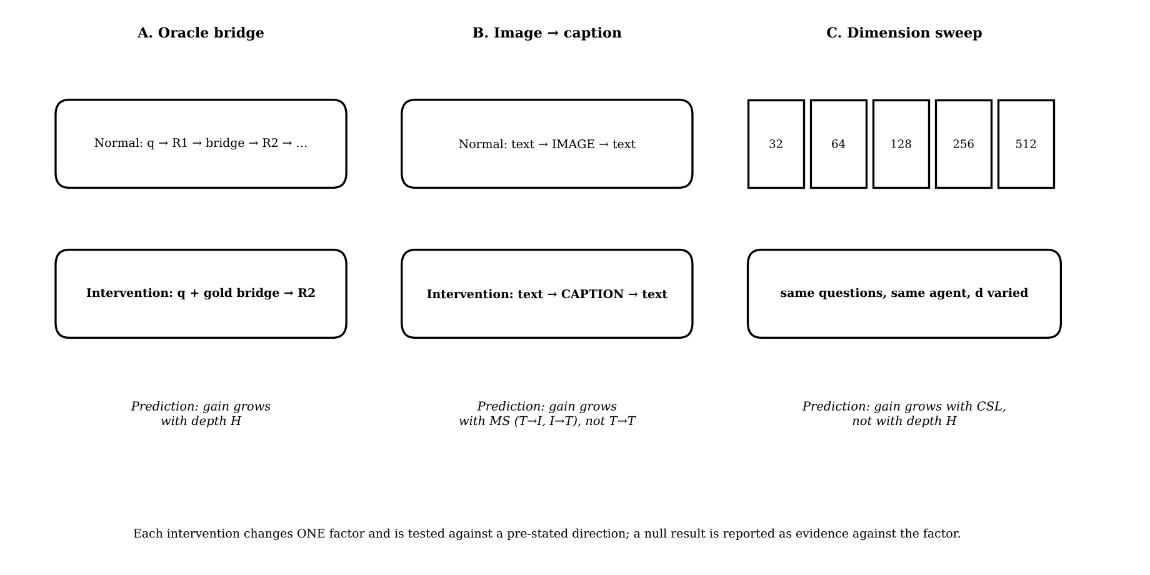
Figure 5. The three intervention experiments with their predicted effects.

12.5 The predictive model and its competitors
Model A (hop count). logit π(q) = α + β·H.
Model B (retrieval-score features). logit π(q) = α + γ·z(q), where z(q) are first-round retrieval-score statistics (top score, margin between top scores, score of the gold item), in the spirit of earlier predictable-failure work [10].
Model C (structural).
logit π(q) = α + β1·H + β2·CSL + β3·MS + β4·log2 d + Σe γe·ne(q) + δ·(H×CSL) + κ·controls + u_q
where ne(q) counts edges of type e and u_q is a question random effect (mixed-effects logistic). Interactions are limited to a pre-registered list (H×CSL, MS×d) to avoid a fishing expedition.
Hop-level model (error propagation). For hop j of question q: logit pj = a + θ(edge type) + φ·CSLj + ψ·log2 d + λ·1[hop j−1 degraded] + u_q. Independence of hops is the special case λ = 0 and var(u) = 0. End-to-end success is composed from the hop model and compared with the measured question-level success.
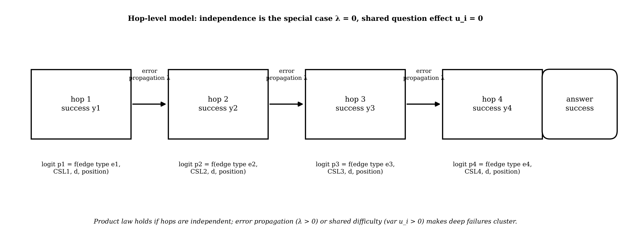
Figure 6. Hop-level model with error propagation; the product law is the independent special case.
Ablations. Hop only; hop + CSL; hop + CSL + MS; full model; and the full model minus each of H, CSL, MS, RC in turn.
Metrics. AUC, Brier score, log-loss, calibration slope and intercept, calibration curve; all out-of-sample by cross-validation grouped by question (all replicates of a question stay in the same fold), then on external datasets.

12.6 Cross-dataset validation
Models are fitted on CrossModalQA, the coefficients are frozen, and predictions are evaluated on VisDocAgentBench, Double-Bench and BrowseComp-V3 (Figure 7). The external datasets differ in modality mix and structure, so their structure variables must be annotated (automatically with a model, then human-checked on a sample). Any dataset in which a variable cannot be annotated reliably is reported as partial transfer.
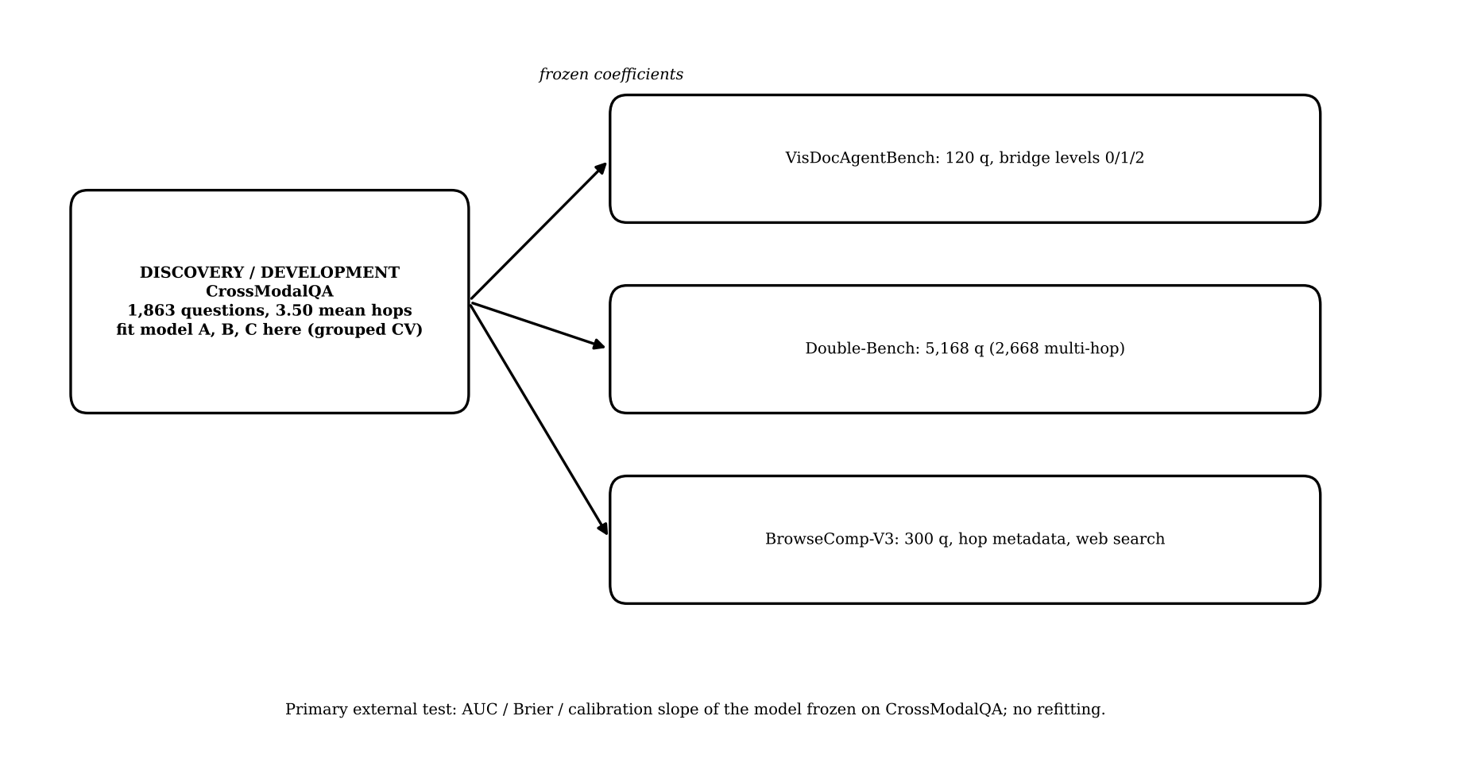
Figure 7. Discovery and external validation design.

12.7 Statistical plan
- Repeated runs of the same question are not independent: use mixed-effects logistic regression with a random intercept for question (and for agent where appropriate), or cluster-robust errors.
- Bootstrap confidence intervals clustered by question for all metric differences (for example ΔAUC of Model C versus Model A).
- Holm correction across the pre-registered family of comparisons; effect sizes reported with intervals.
- Pre-stated success criterion: ΔAUC (C minus A) of at least 0.03 on held-out data with a clustered bootstrap interval excluding zero, and no worse calibration slope. If not met, the paper reports that structure does not add predictive value beyond hop count under the tested conditions.
- Sample size: 1,863 questions × 3 agents × 5 replicates is about 27,900 runs per configuration; cost depends on API prices and image-token counts, which differ across providers by about elevenfold [29], so cost is estimated from a 200-question pilot before scaling.

12.8 Failure analysis
Each failed trajectory is labelled per hop into six mechanisms by replay with gold evidence substituted at the suspected step, then cross-tabulated by edge type, depth and CSL. A human-labelled sample checks the automatic labels, with agreement reported.
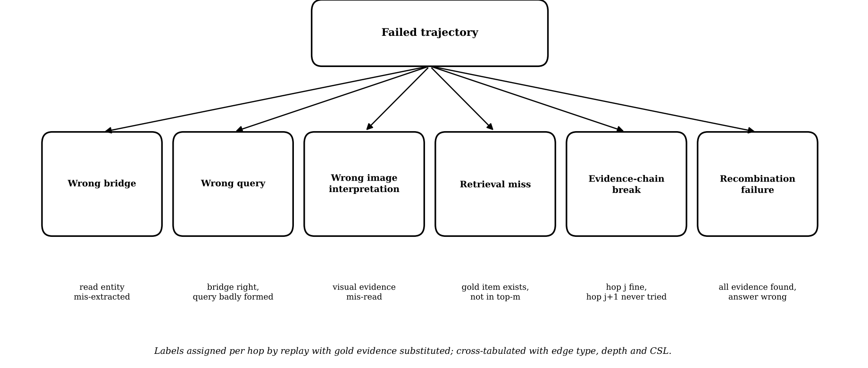
Figure 8. Failure mechanism taxonomy.

12.9 Pipeline summary
Step | Stage | Content
1 | Prepare data | Download datasets, check licences, build the corpus index, record preprocessing.
2 | Annotate structure | Compute H, MS, edge types, CSL from subgraphs; human-check 100 questions.
3 | Pilot | 200 questions, one agent, one retriever: check that structure varies, edge type matters, costs are acceptable.
4 | Main runs | 3 agents × 5 replicates × retrievers d; log per-hop trajectories.
5 | Interventions | Oracle bridge, caption, dimension sweep.
6 | Modelling | Models A, B, C, hop-level model, ablations; grouped cross-validation.
7 | External validation | Frozen coefficients on three datasets.
8 | Failure analysis and report | Mechanism labels, negative results, release artefacts.

13. Our Contributions That Beat Others (Capability Comparison)
Important. This section compares what each line of work provides, not performance. No claim is made that SDM-MAR "beats" any system on accuracy; it is not a competing system. The only defensible sense of "beat" is: provides an analysis capability that existing work does not provide. Whether that capability works is the empirical question of the study.
Table 3. Proposed study versus existing work (capabilities; Y = provided, P = partly, N = not provided, based on the papers read).
Capability | Ours | [1-3] | [4] | [5-7] | [8-10] | [11-14] | [15] | [17-19]
Capability | Ours | [1-3] | [4] | [5-7] | [8-10] | [11-14] | [15] | [17-19]
Multimodal evidence | Y | N | N | N | N | Y | Y | Y
Agentic / multi-round | Y | N | N | Y | Y | P | N | N
Formal statement on rounds or capacity | Y | P | P | N | N | N | N | N
Structural variables per question | Y | N | N | P | N | P | P | N
Concept-separation load separate from depth | Y | N | N | N | N | N | N | N
Modality-switch edges as predictor | Y | N | N | N | N | P | N | P
Predictive model with out-of-sample test | Y | N | N | N | P | N | N | N
Cross-dataset frozen transfer | Y | N | N | N | N | N | N | N
One-factor interventions | Y | N | N | P | N | N | N | P
Repeated runs / P(success|q) | Y | N | N | N | N | N | N | N
Failure mechanism labels | Y | N | N | N | N | N | N | P

Entries for "Ours" are planned capabilities, not yet achieved results. Entries for other work are my reading of abstracts and summaries and may under-credit papers whose full text I did not read.

14. Model Novelty (and Its Honest Limits)
Following the earlier feedback that model novelty alone is not enough for a Q1 venue, the proposal does not rest on model novelty. The "model" in SDM-MAR is a statistical difficulty model, and its novelty is modest:
- Not novel: logistic and mixed-effects regression; predicting success from task features [37]; Fréchet and Bonferroni inequalities; dense and multi-vector retrievers; vision-language agents.
- Moderately novel (composition): the particular structure vector (H, CSL, MS, edge types, RC) for multimodal retrieval chains; the hop-level model with an explicit error-propagation term and the nesting of the product law as the independent case; the edge-type-specific reliability parameters.
- What would raise it: a learned or calibrated difficulty predictor used to route or budget agent computation. This is deliberately left as future work because routing, stopping and budget methods are crowded.
A reviewer who values only architecture will find the proposal thin. The case for it rests on Section 9: a tested explanation with interventions and cross-dataset prediction.

15. References
Bibliographic entries were taken from the arXiv, ACL Anthology, AAAI, GitHub and Hugging Face pages visited during this study. Author lists are given only where they were read; for the others the title and identifier are given and the author list must be completed from the paper page before submission. Entry [37] is incomplete.
[1] LIMIT: On the theoretical limitations of embedding-based retrieval (single d-dimensional vector cannot realise all top-k subsets). arXiv:2508.21038; ICLR 2026. https://arxiv.org/abs/2508.21038
[2] Is dimensionality a barrier for retrieval models? (margin embeddings need d = O(k log(n/k))). arXiv:2605.23556. https://arxiv.org/abs/2605.23556
[3] Multi-vector embeddings are provably more expressive than single-vector embeddings. arXiv:2606.23475. https://arxiv.org/abs/2606.23475
[4] Fano-style accuracy upper bound for single-pass LLM reasoning (accuracy cliff). arXiv:2509.21199. https://arxiv.org/abs/2509.21199
[5] WideSearch: benchmarking agentic broad info-seeking. arXiv:2508.07999. https://arxiv.org/abs/2508.07999
[6] HybridDeepSearcher: scaling parallel and sequential search. arXiv:2508.19113. https://arxiv.org/abs/2508.19113
[7] ExpandSearch: query expansion with reinforcement learning for search agents. arXiv:2510.10009. https://arxiv.org/abs/2510.10009
[8] Iterative retrieval in GraphRAG (empirical study). arXiv:2509.25530. https://arxiv.org/abs/2509.25530
[9] When iterative RAG beats ideal evidence. arXiv:2601.19827. https://arxiv.org/abs/2601.19827
[10] Predictable failure in multi-hop retrieval. arXiv:2609.22056. https://arxiv.org/abs/2609.22056
[11] Hu L., Zhang Y., Li M., Long D., Li Y., Zhang F., Wang Y., Lin Z. VisDocAgentBench: Benchmarking agents for visually rich document retrieval. arXiv:2608.17889, 2026. https://arxiv.org/abs/2608.17889
[12] Shen W., Wang M., Wang Y., Chen D., Yang J., Wan Y., Lin W. Are we on the right way for assessing document retrieval-augmented generation? (Double-Bench). arXiv:2508.03644, 2025. https://arxiv.org/abs/2508.03644
[13] Zhang H. et al. BrowseComp-V3: A visual, vertical, and verifiable benchmark for multimodal browsing agents. arXiv:2602.12876, 2026. https://arxiv.org/abs/2602.12876
[14] MultiHaystack (large mixed-modality corpus, 747 questions). arXiv:2603.05697. https://arxiv.org/abs/2603.05697
[15] Cai J., Hong Z., Yuan Z., Zhou H., Zhang Q., Huang X. CrossModalQA: A cross-modal and multi-hop benchmark for multimodal retrieval-augmented generation. arXiv:2609.05518, 2026. https://arxiv.org/abs/2609.05518
[16] Talmor A., Yoran O., Catav A., Lahav D., Wang Y., Asai A., Ilharco G., Hajishirzi H., Berant J. MultiModalQA: Complex question answering over text, tables and images. ICLR 2021; arXiv:2104.06039. https://arxiv.org/abs/2104.06039
[17] CMC-Bench: cross-modal conflict benchmark. ACL MAGMAR Workshop 2026. https://aclanthology.org/2026.magmar-main.3/
[18] CLASH: image-caption contradiction test cases. CVPR 2026 Findings; arXiv:2511.19199. https://arxiv.org/abs/2511.19199
[19] MMKC-Bench: multimodal knowledge conflict benchmark. AAAI. https://ojs.aaai.org/index.php/AAAI/article/view/39385
[20] AgenticRAG-FP: interventional fault-injection benchmark for agentic RAG. arXiv:2608.20627. https://arxiv.org/abs/2608.20627
[21] Causal Agent Replay. arXiv:2606.08275. https://arxiv.org/abs/2606.08275
[22] Causal attribution for agentic decisions. arXiv:2609.06445. https://arxiv.org/abs/2609.06445
[23] EvidentialRAG: Dirichlet evidence and conflict-preserving Dempster-Shafer fusion. arXiv:2607.10491. https://arxiv.org/abs/2607.10491
[24] VisBrowse-Bench. arXiv:2603.16289. https://arxiv.org/abs/2603.16289
[25] MAGE-RAG: multimodal agentic controller. arXiv:2606.15906. https://arxiv.org/abs/2606.15906
[26] ODE: data evolution for multimodal search agents. arXiv:2605.10832. https://arxiv.org/abs/2605.10832
[27] M3Att: attacks on medical multimodal RAG. arXiv:2605.10253. https://arxiv.org/abs/2605.10253
[28] ConfBench: confidence calibration for document extraction. arXiv:2608.01792. https://arxiv.org/abs/2608.01792
[29] Controlled evaluation of multimodal APIs (image-token counts differ about elevenfold across providers). arXiv:2607.16604. https://arxiv.org/abs/2607.16604
[30] RAG as noisy in-context learning (single-step theory). arXiv:2506.03100. https://arxiv.org/abs/2506.03100
[31] LogicalRAG: agentic retrieval beyond embeddings. arXiv:2605.27123. https://arxiv.org/abs/2605.27123
[32] Benchmarking retrieval-augmented multimodal generation for document question answering (MMDocRAG). arXiv:2505.16470. https://arxiv.org/abs/2505.16470
[33] MMLongBench-Doc: Benchmarking long-context document understanding with visualizations. NeurIPS 2024 D&B; arXiv:2407.01523. https://arxiv.org/abs/2407.01523
[34] LongDocURL: a comprehensive multimodal long document benchmark. ACL 2025; arXiv:2412.18424. https://arxiv.org/abs/2412.18424
[35] MRAMG-Bench: a BeyondText benchmark for multimodal retrieval-augmented multimodal generation. SIGIR 2025; arXiv:2502.04176. https://arxiv.org/abs/2502.04176
[36] MMSearch-Plus: Benchmarking provenance-aware search for multimodal browsing agents. ICLR 2026. https://github.com/mmsearch-plus/MMSearch-Plus
[37] Agent psychometrics: task-level success prediction for agents (reported AUC 0.67 to 0.92). Entry incomplete: bibliographic details were not re-verified in the final check and must be completed before submission. (to be completed)

16. Actual Novelty and What Other Papers Do, Paper by Paper
For each paper: what it does, what is its actual novelty as I read it, and how the present proposal differs. Quoted numbers come from the abstracts or summaries read; where a paper could not be read in full this is stated.
Table 4. Paper-by-paper comparison.
Ref | Paper | What it does (actual novelty) | Limit / what it does not do | Difference from this proposal
[1] | LIMIT | Proves a single d-dimensional vector cannot realise all top-k subsets; builds a dataset where strong embedders get under 20% recall@100. | Dimension-counting limit for one query; names iterative retrieval as unexplored. | Adds multiple rounds and bridge dependence; separates CSL from depth; measures real agents.
[2] | Dimensionality barrier? | Margin embeddings need only d = O(k log(n/k)); matching lower bound. | Counter-theory to [1]; single stage. | Used to bound our CSL conjecture; no rounds.
[3] | Multi-vector expressiveness | Exponential dimension lower bound for approximating Chamfer similarity with inner products. | Static expressiveness gap. | Our RC includes retriever type; tests it empirically.
[4] | Fano-style bound | Accuracy bounded when information demand exceeds capacity. | Closed-book single-pass; excludes retrieval and agents. | Retrieval-based agents, measured, multimodal.
[5] | WideSearch | Benchmark of broad information gathering; best system about 5%. | Establishes wide tasks are hard. | We study depth versus separation, with images, predictively.
[6] | HybridDeepSearcher | Parallel and sequential search; +15.9 F1 on FanOutQA. | Method. | No method; explains when each helps.
[7] | ExpandSearch | RL-trained multi-query expansion; +4.4% average; cites [1]. | Method; empirical. | No method; we test the dimension link.
[8] | GraphRAG iterative retrieval | Iteration helps bridge-heavy questions. | Observational, text. | Interventional and multimodal.
[9] | Iterative RAG beats ideal evidence | +3.74% on 2Wiki, +8.41% on MuSiQue; no help on single-hop; bridge docs beyond top-10. | Text; no structure model. | Structure predicts when it helps.
[10] | Predictable failure in multi-hop retrieval | Failures cluster and are predictable from retrieval features. | Text; features are scores. Not read in full. | Model B baseline; we add structure.
[11] | VisDocAgentBench | Bridge levels; 97.50% R@1 direct versus 2.50% two-bridge; best agent 67.50%; 120 queries. | Measurement of collapse; small. | External validation set; we explain and predict.
[12] | Double-Bench | 5,168 queries (2,668 multi-hop), 72,880 pages, six languages. | Large document RAG benchmark; hop depth beyond two unclear. | External validation set.
[13] | BrowseComp-V3 | 300 questions, expert sub-goals; humans 68%, best model 39%; web browsing. | Benchmark with trajectories. | External validation; trajectory analysis.
[14] | MultiHaystack | 46,000 items, 747 questions; 80.86% with gold, 51.4% with top-5 retrieval. | Shows retrieval bottleneck; structure not stated. | Possible additional transfer set.
[15] | CrossModalQA | 1,863 QA, 4,987 Wikipedia articles, 4,431 images, mean 3.50 hops, subgraphs kept. | Benchmark; LLM-generated with filtering; no code or data link found. | Primary dataset; we use its subgraphs to annotate structure.
[16] | MultimodalQA | About 30,000 questions over text, tables, images; ImplicitDecomp F1 51.7 on cross-modal, humans 90.1. | Classic multimodal multi-hop QA; no agent. | Fallback source for structure.
[17] | CMC-Bench | 3,768 conflict instances; accuracy drops 0.17-0.46. | Engineered conflicts; static. | Different question (conflict), may be future link.
[18] | CLASH | 1,289 human-verified image-caption contradictions. | Not retrieval or agentic. | Not overlapping.
[19] | MMKC-Bench | 1,881 knowledge instances; models favour internal knowledge. | Not agentic. | Not overlapping.
[20] | AgenticRAG-FP | Fault injection at a hop; diagnosers find hop-1 faults (0.91) but not later (0.00). | Text; tiny samples. | We label failure mechanisms in multimodal chains.
[21] | Causal Agent Replay | Structural causal model and Shapley credit for agent runs. | General agents. | Methodological tool for our replay.
[22] | Causal attribution for agentic decisions | Marginal vs common-random-number effects; logging specification. | Specification; experiment not run. | Estimand definitions for our interventions.
[23] | EvidentialRAG | Dempster-Shafer fusion; hallucination 45.3% to 34.8% on CRAG. | Text; not agentic. | Not overlapping.
[24] | VisBrowse | Image-centric browsing benchmark. | Not read in detail. | Possible transfer set.
[25],[26] | MAGE-RAG, ODE | Controller / data-evolution methods for multimodal agents. | Methods. | No method; difficulty explanation.
[27],[28],[29] | M3Att, ConfBench, controlled evaluation | Attack on medical MM-RAG; confidence calibration; image-token cost differences. | Not about structure. | [29] informs cost planning.
[30],[31] | RAG as noisy ICL; LogicalRAG | Single-step RAG theory; agentic retrieval beyond embeddings. | [31] not read in detail. | Background.
[32]-[36] | MMDocRAG, MMLongBench-Doc, LongDocURL, MRAMG-Bench, MMSearch-Plus | Document and search benchmarks (see Appendix A). | Structure not annotated for difficulty. | Candidate secondary datasets.
[37] | Agent psychometrics | Per-task success prediction, AUC 0.67-0.92. | Not retrieval-structure; entry incomplete. | Methodological precedent.
- | Unread: arXiv 2609.38743 (multi-step embedding retrieval); 2609.38222 | Not read (rate-limited). | Possible overlap. | Must be read before submission.

Appendix A. Dataset Table (Public, Gated and Private)
Sizes are the content sizes stated by the papers or pages. Disk size (GB) was not verifiable in this study, because the dataset hosting API could not be queried; it must be read from each repository page before download. Access status is as read from the pages and must be re-checked.
Table 5. Multimodal datasets for the study.
Dataset | Content | Stated size | Role | Access and links
CrossModalQA [15] | Wikipedia text plus Wikimedia Commons images; subgraphs of supporting evidence | 1,863 QA; 4,987 articles; 4,431 images; mean 3.50 hops | Primary (discovery) | Access NOT verified: the paper lists no code or data link. Plan: write to the authors; fallback: rebuild structure on MultimodalQA, or switch the primary set. https://arxiv.org/abs/2609.05518
VisDocAgentBench [11] | Pages of arXiv papers (visually rich); bridge levels L1-L3 | 2,375 pages from 100 papers; 120 queries | External validation | Project page: https://hulx2002.github.io/VisDocAgentBench ; per-document arXiv licences.
Double-Bench [12] | Multilingual document pages; single and multi-hop queries | 3,276 documents; 72,880 pages; 5,168 queries (2,668 multi-hop) | External validation | Public; CC BY 4.0 stated. Project: https://double-bench.github.io/
BrowseComp-V3 [13] | Web browsing, text and images; expert sub-goals | 300 questions | External validation | Earlier check: Hugging Face release with encryption, CC BY 4.0 (gated-style, needs key). Re-verify. https://arxiv.org/abs/2602.12876
MultimodalQA [16] | Text, tables and images from Wikipedia | 29,918 questions | Fallback / secondary | Public (release repository to be confirmed). https://arxiv.org/abs/2104.06039
MMDocRAG [32] | Long documents with text, table, chart, image quotes | 4,055 QA; 222 documents | Secondary | Public. https://huggingface.co/datasets/MMDocIR/MMDocRAG ; https://mmdocrag.github.io/MMDocRAG/
MMLongBench-Doc [33] | Long PDF documents with figures and tables | 130 documents; 1,062 questions | Secondary | Public. https://huggingface.co/datasets/yubo2333/MMLongBench-Doc ; https://github.com/mayubo2333/MMLongBench-Doc
LongDocURL [34] | Long multimodal documents | 2,325 QA; more than 33,000 pages | Secondary | Public. https://huggingface.co/datasets/dengchao/LongDocURL ; https://github.com/dengc2023/LongDocURL
MRAMG-Bench [35] | Multimodal answer generation; documents and images | 4,800 QA; 4,346 documents; 14,190 images | Secondary | Public. https://huggingface.co/datasets/MRAMG/MRAMG-Bench ; https://github.com/MRAMG-Bench/MRAMG
MultiHaystack [14] | Large mixed-modality corpus | 46,000 items; 747 questions | Optional transfer | https://arxiv.org/abs/2603.05697 (access not verified)
MMSearch-Plus [36] | Multimodal browsing, provenance-aware | Not verified | Optional transfer | https://github.com/mmsearch-plus/MMSearch-Plus ; https://huggingface.co/datasets/Cie1/MMSearch-Plus (gated or encrypted status not verified)
VisBrowse [24] | Image-centric browsing | Not verified | Optional transfer | https://arxiv.org/abs/2603.16289
Private / own layer | Structural annotations (H, CSL, MS, edge types), 100-question human validation set, agent run logs, caption set | Built in this study | Our contribution | Private during the study; released after the work is accepted or earlier if permitted by source licences.

What else can be applied. (1) A synthetic generator with planted chains for controlled tests of H, CSL and d (already prototyped, Appendix C). (2) MultimodalQA and Wikipedia to rebuild evidence subgraphs if CrossModalQA cannot be obtained. (3) Domain corpora (for example scientific figures with captions) for the application claims in Section 11; these need separate permissions and are outside the core plan. (4) Public text multi-hop datasets (MuSiQue, 2WikiMultiHopQA) as a text-only control for the depth and CSL claims; these were used by the papers cited in [8,9] and their licences must be checked.

Appendix B. Structural Annotation Protocol and Human Validation
- Take the question, its gold evidence items and any provided supporting subgraph.
- Build G(q): nodes are evidence items with modality; draw an edge j to j+1 only if the entity or value needed to query j+1 appears in j and not in q.
- Compute H, MS and edge-type counts from G(q).
- Compute CSL from the retriever's neighbourhood around each gold item (primary) and from distinct concept constraints (secondary).
- Two annotators independently annotate 100 questions stratified by H and MS; disagreements resolved by discussion; report kappa and ICC.
- Report the distribution of H, MS and edge types; if almost every question has the same structure, the study design is invalid and is stopped (go/no-go).

Appendix C. Pilot Results (Idealised Simulation)
What was run. A synthetic corpus of 5,000 documents with 150 planted evidence chains at each depth 1 to 4, hard-negative distractors that share topic words with questions, real dense embeddings of controlled dimension d (tf-idf plus truncated SVD, 8 to 512) plus a sparse baseline, and an idealised rule-based agent that builds each next query from the bridge entity it just read. Three random seeds. Neural encoders could not be downloaded in the sandbox, and no LLM was used.
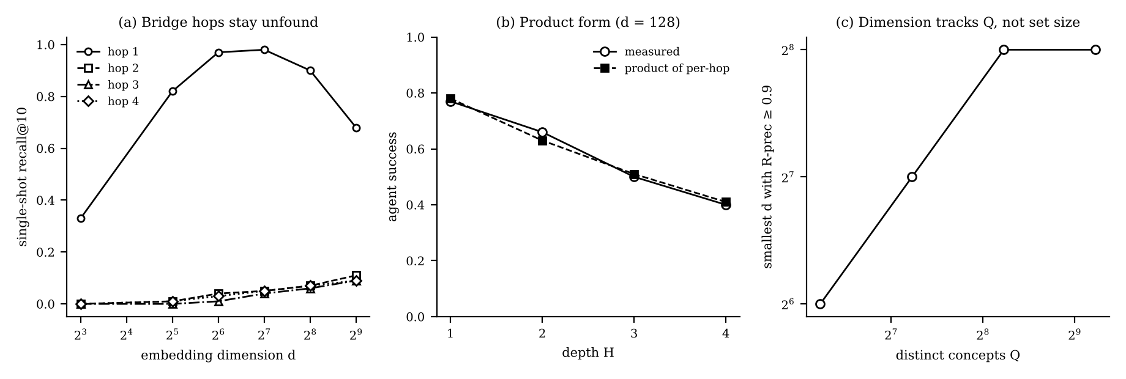
Figure 9. Pilot results: (a) single-shot recall of bridge hops, (b) agent success versus depth against the product of per-hop success, (c) smallest dimension reaching R-precision 0.9 versus number of distinct concepts.
- Depth supported (partly by construction). Hop 1 recall reaches 0.98 at d = 128; hops 2 to 4 stay at 0.00-0.11 at all d. The corpus was designed so that later hops are bridge-blind, so this is a harness check, not a discovery.
- Product form fits within 0.01-0.05 mean absolute error in this simulation, but with independent hops this is almost arithmetic. It says nothing about real agents.
- Dimension effect is non-monotone (best around 128-256), a quirk of this corpus.
- Width conjecture refuted. Larger relevant sets were easier; the needed dimension tracked the number of distinct concepts Q (d* = 256, 256, 128, 64 for Q = 600, 300, 150, 75). This led to replacing "width" by concept-separation load.
Limitation. Idealised agent, LSA embeddings and a built-in bridge-blind design. Real multimodal agents may behave very differently.

Appendix D. Risks, Go/No-Go Rules and Timeline
Table 6. Risks and mitigation.
Risk | Effect | Mitigation
CrossModalQA unavailable or unreleased | Primary dataset cannot be used. | Contact authors; fall back to MultimodalQA/Wikipedia subgraphs or a verified public set such as Double-Bench or MMDocRAG; adjust story.
Structure is LLM-generated (annotation noise) | Blurred effects. | 100-question human validation; sensitivity analysis.
Structure nearly constant | No variation to explain. | Stop rule after annotation (Appendix B).
Real agents show dependent hops | Product law fails; theory looks thin. | This is a finding; the hop-level model reports it.
Theory seen as trivial | Weak formal contribution. | State plainly; strengthen with measurable A1 and tight dependence bounds; seek a theory-minded co-author.
External sets lack structure labels | Transfer partial. | Annotate by model plus human sample; report partial transfer.
API cost and image-token variation | Budget overrun. | 200-question pilot; cost model before scaling [29].
Overlap with unread papers (2609.38743 and CrossModalQA path categories) | Novelty reduced. | Read before committing; update Section 8.
No Q1 guarantee | Rejection. | Design for what reviewers check: assumptions, replicates, out-of-sample, limits.

Table 7. Go/no-go rules.
Checkpoint | Go criterion | If not met
After annotation | H, MS and edge types vary substantially. | Else stop or change dataset.
After pilot (200 q, one agent) | Edge type or depth clearly changes success. | Else rethink factors.
After main runs | ΔAUC (C minus A) ≥ 0.03 with interval excluding 0 on held-out data. | Else report negative result.
After transfer | Frozen model keeps AUC advantage on at least two external sets. | Else claim dataset-specific effects only.

Table 8. Timeline (indicative, about 6 months).
Period | Work | Output
Month 1 | Data access, annotation code, 100-question human validation, read unread papers | Dataset check
Month 2 | Pilot with one agent; edge-type reliability | Pilot decision
Months 3-4 | Main runs, interventions, dimension sweep | Run logs
Month 5 | Modelling, ablations, external validation, failure analysis | Results
Month 6 | Writing, theory polishing, artefact release | Manuscript

Appendix E. Reproducibility Checklist and Requirement Coverage
- Release dataset preprocessing, structural annotation code, retrieval configuration, prompts, model settings, seeds, repeated-run protocol, evaluation code and statistical analysis code.
- For API models record exact model name, version, date, temperature and tool configuration; store raw trajectories.
- Pre-register the model list, interaction terms, CSL definitions, success criterion and exclusion rules before the main runs.
Table 9. Where each of the 16 requested items appears.
No. | Item | Location
1 | Title of the proposed model | Section 1
2 | Introduction | Section 2
3 | Problem statement | Section 3
4 | Short literature review (table) | Section 4, Table 1
5 | Research questions | Section 5
6 | Research objectives | Section 6
7 | Already established | Section 7
8 | Specifically new | Section 8
9 | Core (scientific) novelty | Section 9, Table 2
10 | Main research contribution | Section 10
11 | Related applications | Section 11
12 | Proposed model framework and diagrams | Section 12, Figures 2-8
13 | Contributions versus others (table) | Section 13, Table 3
14 | Model novelty | Section 14
15 | References | Section 15
16 | Paper-by-paper novelty (table) | Section 16, Table 4

